Part A3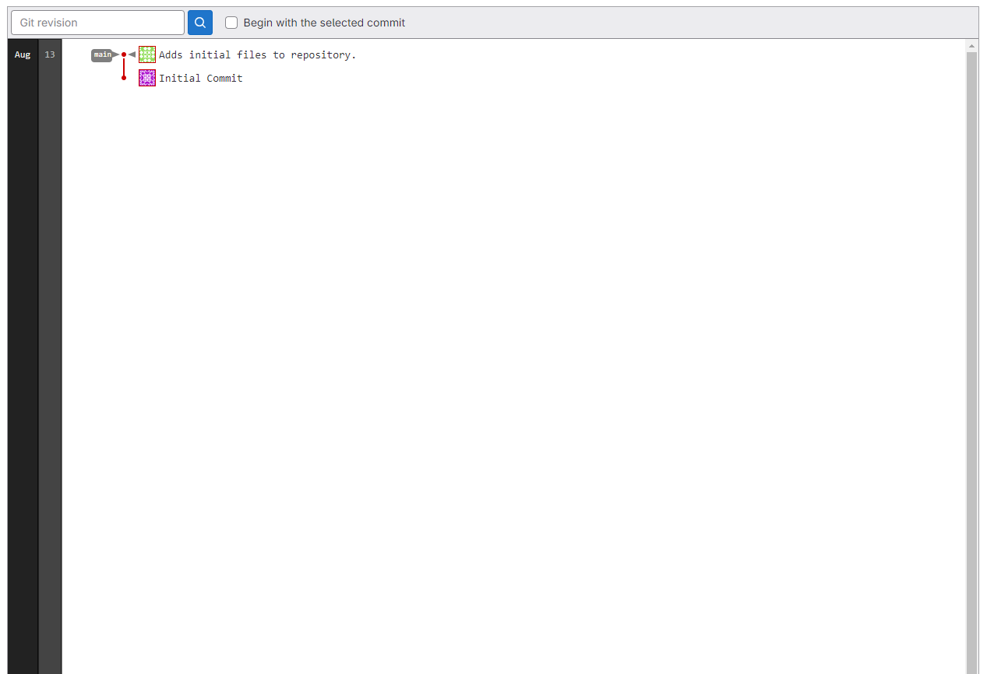Part B

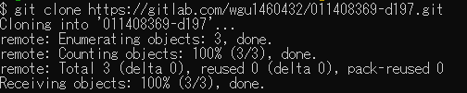

Part C1a

Part C1b

Part C1c

Part C2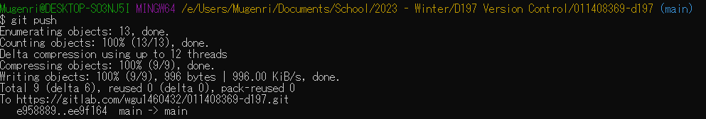

Part D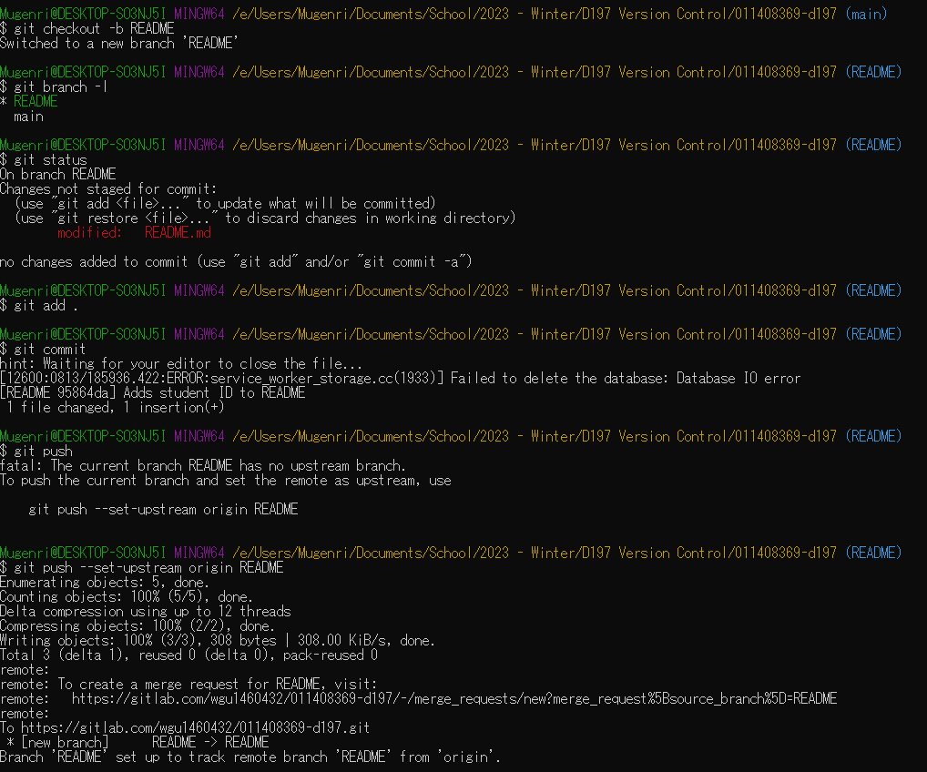

Part D1

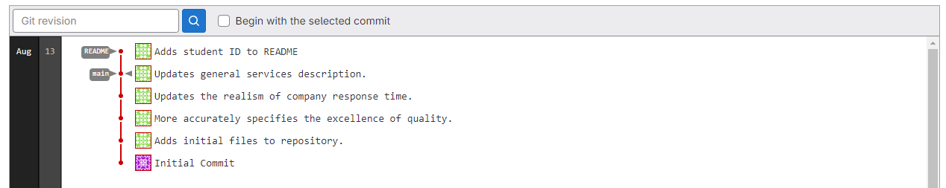

Part E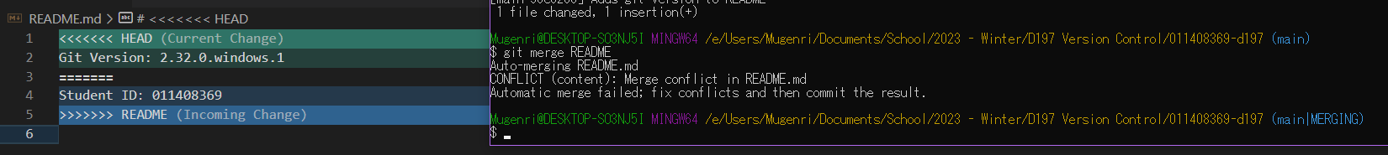

Part E1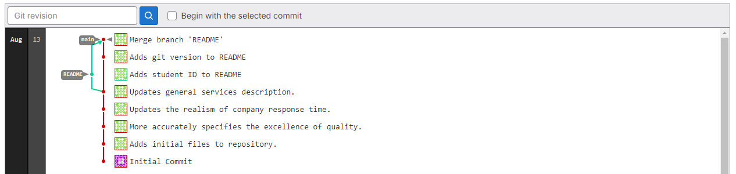

Part F

Part F1